**Project Selection:**

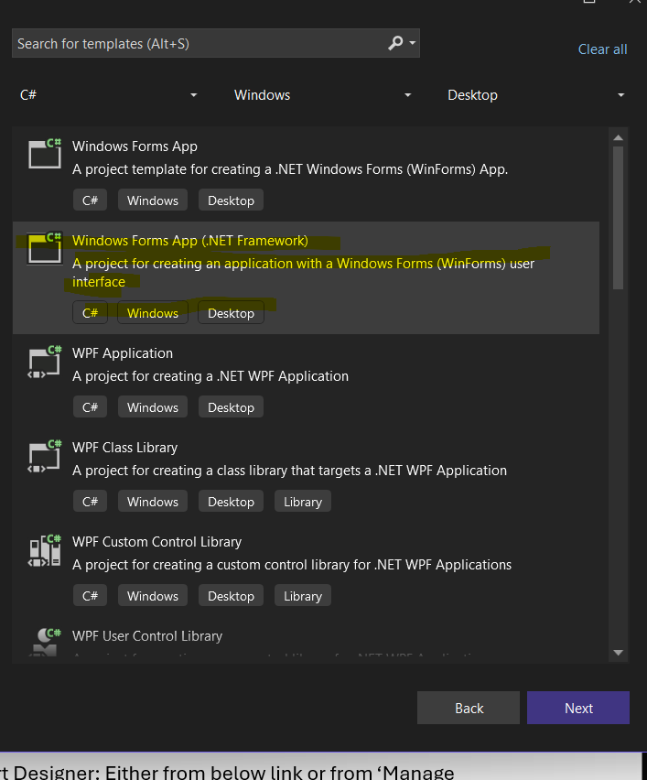

**References:**

<https://www.youtube.com/watch?v=WgpHwDnHaxs&ab_channel=CodeEngineers>(How to install RDLC Report Designer and Report Viewer)

<https://www.youtube.com/watch?v=E5vtKS8ZlRU&ab_channel=FoxLearn>(C# Tutorial - How to generate QR Code in RDLC Report)

<https://www.youtube.com/watch?v=-Mzd_JLS-Gs&ab_channel=ProgrammingGeek> (Create RDLC Report in C# with SQL Step By Step)

**Prerequisites:**

* Download Microsoft RDLC Report Designer: Either from below link or from ‘Manage Extension’ in Visual Studio.

<https://marketplace.visualstudio.com/items?itemName=ProBITools.MicrosoftRdlcReportDesignerforVisualStudio-18001>

* Download ‘QRCoder’ from NuGet Packages in Tools pane in visual studio.
* Download ‘Report Viewer’ from NuGet Packages.



* You can add Report from toolbox like in image below.

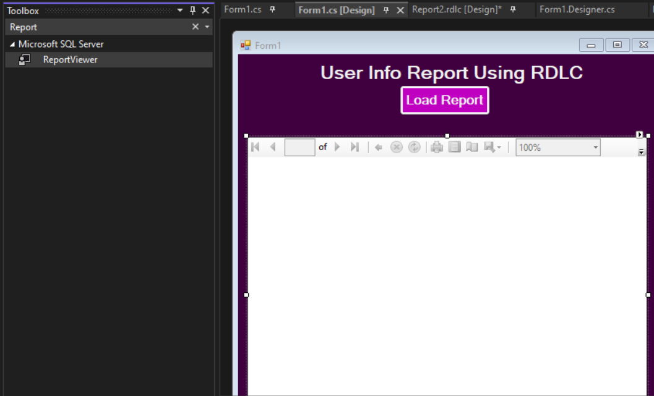

**FormDesign**:

* Create a button to Load Report into a Report Viewer.

**RDLC Report:**

* Create rdlc report in your directory.
* Page Break Logic works only when grouping is used. To implement this logic, we added a ‘List’. Then inside this list multiple fields will be encapsulated depending upon the requirement.
  + Right click on the list row, then select Row Group, then click Group Properties.
  + There will be navigation menu. Select Page Breaks.
  + There will be a check box of Page break options. Select it accordingly and click ok.

* IMPLEMENTING QRCODE LOGIC INSIDE OUT LIST:
  + There will be an image field in your list to implement QRcode logic.
  + Add a new column named QRCodeImage to the DataSet. This column will store the generated QR code images on runtime. Type of this column will be Byte Array. After adding, this column will be shown in Data Source pane.

* GENERATE QR CODES:

The above GenerateQRCode function is used in below logic to implement generic QR’s respective to a row of datatable inside out list.

